**Programs**

**[1] DFA Which Accepts Strings Start With ‘A’ And End With ‘A’**

#include <stdio.h>

#include <stdbool.h>

#include <string.h>

int dfa_transition(int state, char input)

{

if (state == 0 && input == 'a')

return 1;

else if (state == 1 && input == 'a')

return 1;

else

return 0;

}

bool simulate_dfa(const char *input)

{

int current_state = 0;

int input_length = strlen(input);

for (int i = 0; i < input_length; i++)

current_state = dfa_transition(current_state, input[i]);

return current_state == 1;

}

int main()

{

char input[100];

printf("Enter a String : ");

scanf("%s", input);

if (simulate_dfa(input))

printf("String Accepted.\n");

else

printf("String Not Accepted.\n");

return 0;

}

**Algorithm**

Initialize current state = q0 (start state).

For each symbol in the input string:

Apply the transition function: current state = δ (current state, symbol)

If the last symbol in the input string is 'A' and current state is q2, then the input string is accepted. Otherwise, it is rejected.

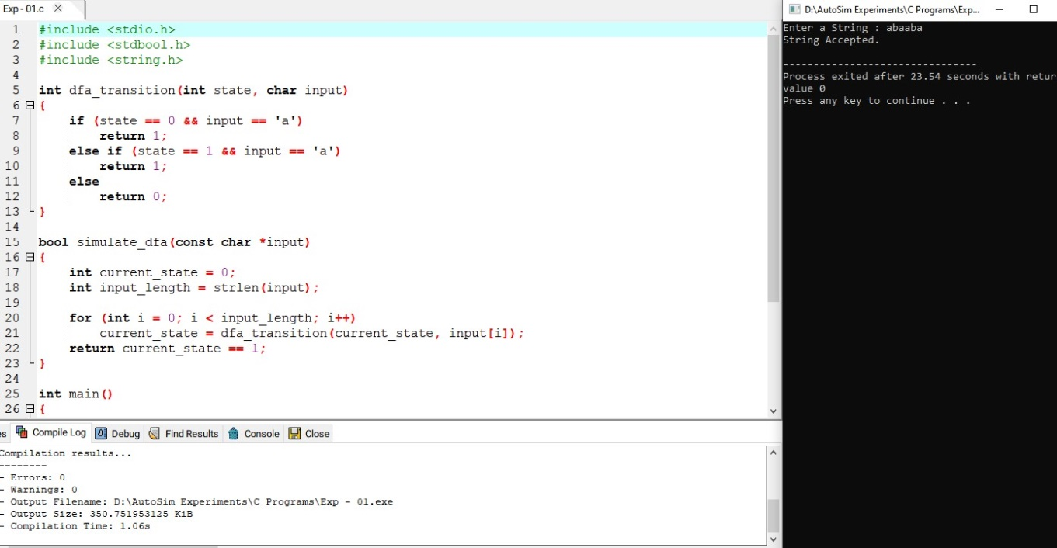

**Result**

Thus we have successfully implemented and executed the program and the strings given as inputs are verified